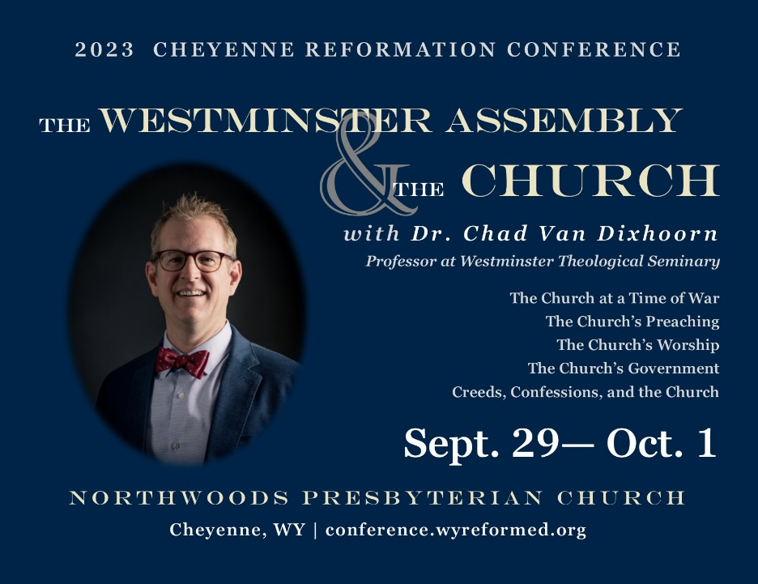
Get more information and register for the conference at:
https://conference.wyreformed.org
Get more information and register for the conference at:
https://conference.wyreformed.org

